**DIRECTIONS for using Naviance to complete the resume and job app.**

***How to complete and upload the Job Application in Naviance***

* Cbsd.org
* Students
* On the left click Career Plan (High School)
* Scroll to the bottom and click on the job application link and complete and save your document.
* Log into your Naviance account
* About me tab
* Scroll down to interesting things about me and click on journal
* Add new journal entry
* Type = other
* Subject = Job Application
* Share with – check counselors and teachers.
* Scroll down and hit browse and find saved document, hit attached and then scroll down to the bottom and click on add journal entry

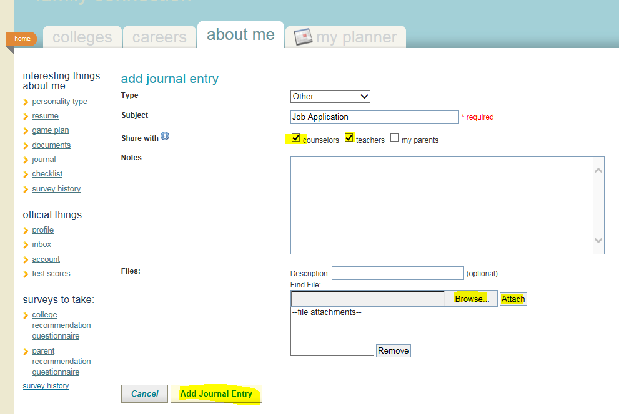

***To complete resume***

- About me tab

- Interesting things about me - click on resume

- complete drop down tabs in Add New Entry

- must complete Objective, Education and References, plus 2 other of your choice. (ex: Work experience, awards, etc.)

